CENWP-OD-B 4 October 2022

MEMORANDUM FOR THE RECORD

SUBJECT: 22BON093 MFR AFF Braille Pool Mortality

On 4 October, Columbia River Inter-Tribal Fish Commission (CRITFC) Biologists notified Bonneville Project Biologists of a Salmonid mortality found on the ground near the Braille pool in the Adult Fish Facility (AFF). The fish was scanned for PIT tags, inspected, and returned to the river.

- Species – Salmonid Spp.
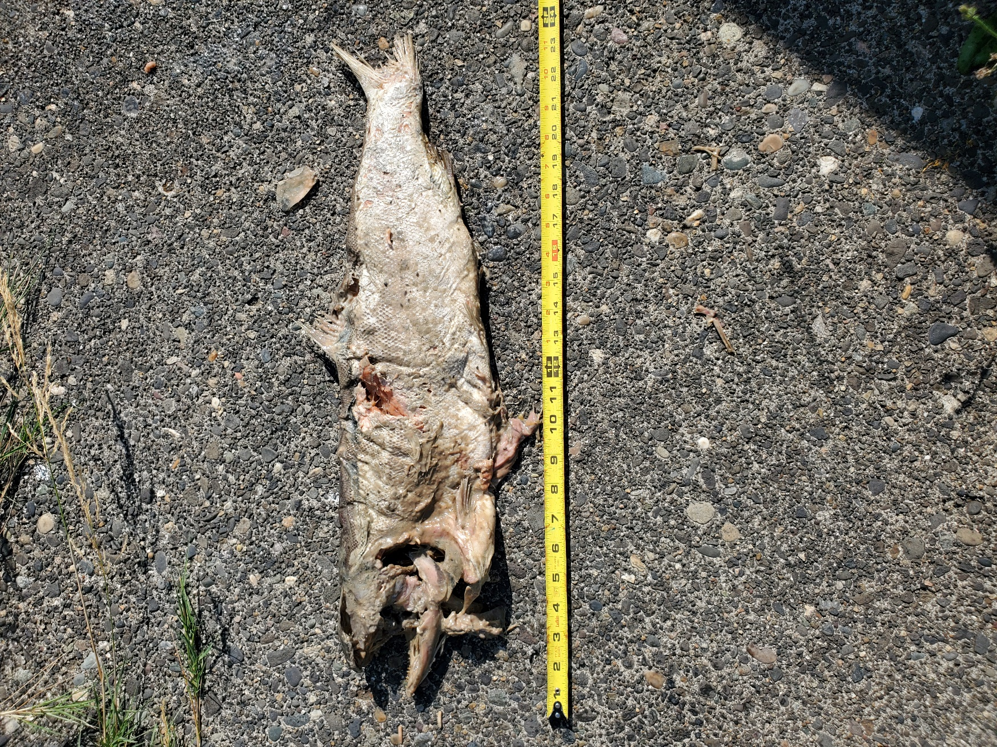
- Origin – Unknown
- Length – 60.3 cm
- Marks and tags – None
- Marks and Injuries found on carcass – Decay
- Cause and Time of Death – Unknown.
- Future and Preventative Measures – None

Sincerely,
Bonneville Project Fisheries

